// -------------------------- **How to Run the SOAP API** --------------------------------------------

Step 1: login to your Org

Step 2: go to set-up search API and click Enterprise WSDL

Step 3: you will redirected to another url save the xml file in your local

step 4: Open SOAP Application, if not installed in your system then download it from https://www.soapui.org/downloads/soapui/soapui-os-older-versions/#_ga=2.259719434.1029072957.1625854027-936478644.1625854027

Step 5: After Open Application click Create New Project Give the Project Name and upload the wsdl file that you have downloaded. Click Save

Step 6: Go To Project Section and open Login "Request1" and Write below script::

Here---

Username:<ORG_USERNAME> like: dksharma8115@curious-otter-93loxd.com

password:<OrgPassword><SecurityTOken> like: Dhar@8115xnCoepgBs6M8OU8UGEt6RlGdo

------------------------------------------------------------------------------------

<soapenv:Envelope xmlns:soapenv="http://schemas.xmlsoap.org/soap/envelope/" xmlns:urn="urn:enterprise.soap.sforce.com">

<soapenv:Header>

</soapenv:Header>

<soapenv:Body>

<urn:login>

<urn:username>dksharma8115@curious-otter-93loxd.com</urn:username>

<urn:password>Dhar@8115xnCoepgBs6M8OU8UGEt6RlGdo</urn:password>

</urn:login>

</soapenv:Body>

</soapenv:Envelope>

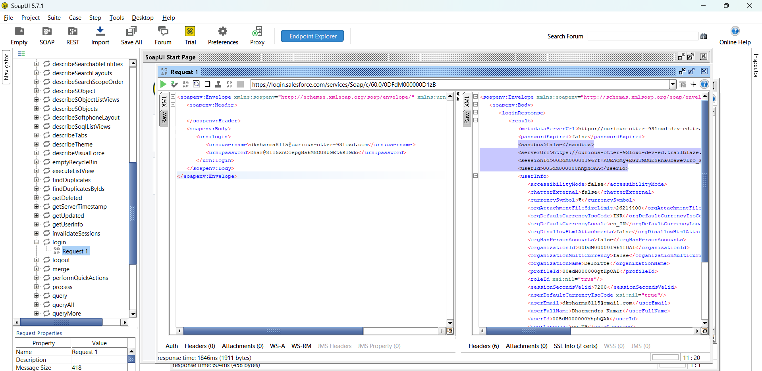

------------------------------------------------------------------------------------------------

Step 7: Click on Submit the Request you will get the reponse in XML format if everything is correct

Step 8: Note down the below information for future:

----------------------------------------------------------------------------------------------------

<serverUrl>https://curious-otter-93loxd-dev-ed.trailblaze.my.salesforce.com/services/Soap/c/60.0/00DdM00000196Yf/0DFdM000000D1zB</serverUrl>

<sessionId>00DdM00000196Yf!AQEAQMy4EGuTMOuESRna0baWevLro_zt2DsLN2xsfwo0a0fSbILyPlu6ZJ9AjpOHWCCiDxzBq4R3VMqEVQhgRe0WHFCqJLRW</sessionId>

<userId>005dM000000hhphQAA</userId>

-------------------------------------------------------------------------------------------------------

Step 9: Now you are good to go to create Records

Step 10: For Creating Record go to Project Section Expand Create and Click on Request1

Step 11: Give the below information for XML

--------------------------------------------------------------------------------------------------------------------------------------------

<soapenv:Envelope xmlns:soapenv="http://schemas.xmlsoap.org/soap/envelope/" xmlns:urn="urn:enterprise.soap.sforce.com" xmlns:urn1="urn:sobject.enterprise.soap.sforce.com">

<soapenv:Header>

<urn:SessionHeader>

<urn:sessionId>00DdM00000196Yf!AQEAQMy4EGuTMOuESRna0baWevLro_zt2DsLN2xsfwo0a0fSbILyPlu6ZJ9AjpOHWCCiDxzBq4R3VMqEVQhgRe0WHFCqJLRW</urn:sessionId>

</urn:SessionHeader>

</soapenv:Header>

<soapenv:Body>

<urn:create>

<!--Zero or more repetitions:-->

<urn:sObjects xsi:type="urn1:Account" xmlns:xsi="http://www.w3.org/2001/XMLSchema-instance">

<Name>Bluebeards Coconut Milk House</Name>

<Description>It is better than Blackbeards.</Description>

</urn:sObjects>

</urn:create>

</soapenv:Body>

</soapenv:Envelope>

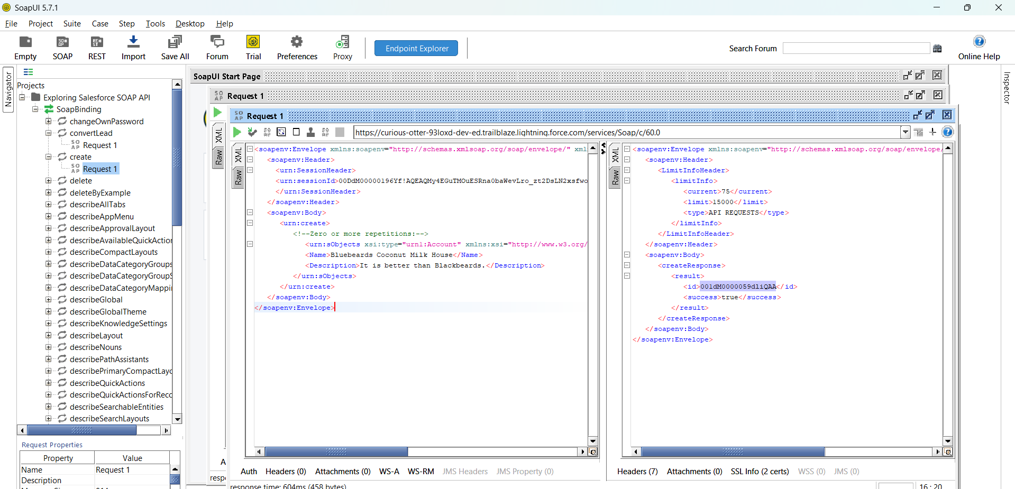

-------------------------------------------------------------------------------------------------------------------------------------------------

Step 12: SessinId you can copy paste from Step 8 that you got, BTW I an creating here Account Record that information you can see from line number 73 to 75.

Step 13:URL should be your OrgBaseURL/services/Soap/c/60.0

Step 14: Submit the Request and you will get the response., validate the record is created in the org with RecordId